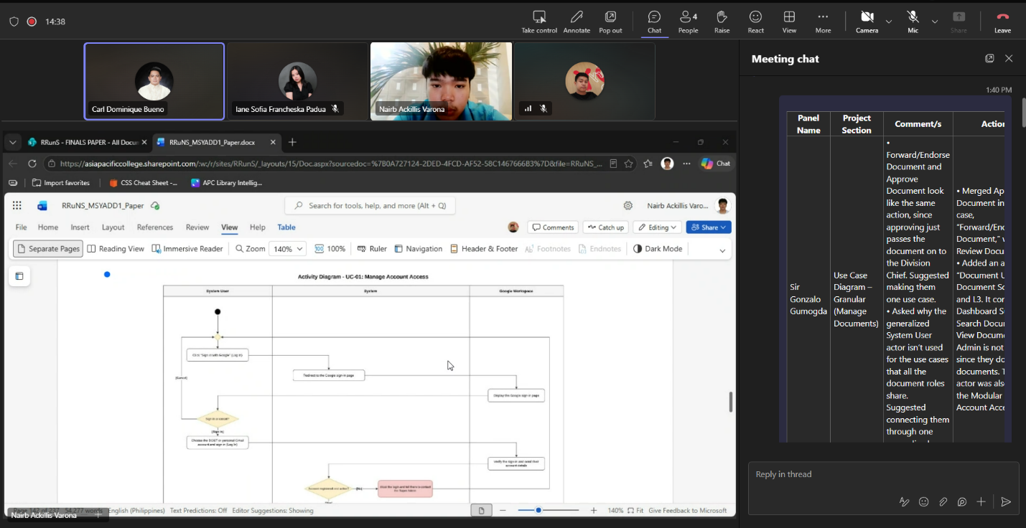
Weekly Status Report: Minutes of Meeting
- Date: Wednesday, November 4, 2026
- Meeting Called By: RRuNS Team
- Facilitator: Sir Dom Bueno (New Project Adviser)
- Link of the Meeting: Recap: Project Consultation with Sir Dom Bueno(new project adviser) Wednesday, 4 November | Meeting | Microsoft Teams
1. Attendees
- Nairb Ackillis Varona
- Romeo Jr. Albeza
- Iane Sofia Francheska Padua
- Raniel Q. Dela Cruz

2. Agenda
- Consult our paper and the diagrams
- Discussion of the development of the system
3. Summary
- Status update for the week:
  - The team conducted a consultation with the new project adviser, Sir Dom Bueno, to review the current research paper draft and system diagrams.
  - Discussed the ongoing development roadmap, technical implementation details, and upcoming system milestones to align with the adviser's expectations.
- Blockers/Obstacle that encountered this week:
  - Transitioning project feedback from the new adviser and integrating their recommendations into the paper, diagrams, and system development pipeline.

